For Project Management System:

CREATE DATABASE project_management_system;

For Employee Table:

1. CREATE TABLE employee ( EmployeeID INT AUTO_INCREMENT PRIMARY KEY,    Employee_Name VARCHAR(50), Email_Id VARCHAR(50), Monthly_logged_hours INT);
2. INSERT INTO employee (EmployeeID, Employee_Name, Email_Id, Monthly_logged_hours) VALUES ('2','Ram Sharma','r.sharma@gmail.com','20');
3. INSERT INTO employee (EmployeeID, Employee_Name, Email_Id, Monthly_logged_hours) VALUES ('2','Roy Mishra','r.mishra@gmail.com','15');
4. INSERT INTO employee (EmployeeID, Employee_Name, Email_Id, Monthly_logged_hours) VALUES ('3','Vani Kapoor','v.kapoor@gmail.com','10');
5. INSERT INTO employee (EmployeeID, Employee_Name, Email_Id, Monthly_logged_hours) VALUES ('4','Neerja Khan','n.khan@gmail.com','10');
6. INSERT INTO employee (EmployeeID, Employee_Name, Email_Id, Monthly_logged_hours) VALUES ('5','Simran Rai','s.rai@gmail.com','20');

For Project table:

1. CREATE TABLE Project ( ProjectID INT AUTO_INCREMENT PRIMARY KEY, Project_Name VARCHAR(50), Project_ETA INT, Project_Coordinator INT,Project_Date Date);
2. INSERT INTO PROJECT VALUES ('101','Project1','100','2','2017-05-13')
3. INSERT INTO PROJECT VALUES ('102','Project2','500','5','2017-02-02')
4. INSERT INTO PROJECT VALUES ('103','Project3','140','2','2017-01-01')
5. INSERT INTO PROJECT VALUES ('104','Project4','250','4','2017-06-20')

For Project Member table:-

1. CREATE TABLE PROJECT_MEMBERS (Member_Id INT AUTO_INCREMENT PRIMARY KEY , ProjectID INT NOT NUll, EmployeeID INT NOT NULL,FOREIGN KEY fk_project(ProjectID) REFERENCES project(ProjectID), FOREIGN KEY fk_employee(EmployeeID) REFERENCES employee(EmployeeID));
2. INSERT INTO `project_members`(`Member_Id`, `ProjectID`, `EmployeeID`) VALUES ('1','101','4')
3. INSERT INTO `project_members`(`Member_Id`, `ProjectID`, `EmployeeID`) VALUES ('2','102','1')
4. INSERT INTO `project_members`(`Member_Id`, `ProjectID`, `EmployeeID`) VALUES (‘3’,’103’,’5’)
5. INSERT INTO `project_members`(`Member_Id`, `ProjectID`, `EmployeeID`) VALUES (‘4’,’101’,’1’)
6. INSERT INTO `project_members`(`Member_Id`, `ProjectID`, `EmployeeID`) VALUES (‘5’,’103’,3)
7. INSERT INTO `project_members`(`Member_Id`, `ProjectID`, `EmployeeID`) VALUES (‘6’,’101’,’3’)
8. INSERT INTO `project_members`(`Member_Id`, `ProjectID`, `EmployeeID`) VALUES (‘7’,’102’,’4’)

For Project Forecast:-

1. CREATE TABLE project_forecast (Forecast_Id INT AUTO_INCREMENT PRIMARY KEY, Member_Id INT NOT NUll, Forecast_hours DECIMAL (11,2), Forecast_monday DATE, FOREIGN KEY fk_memb(Member_Id) REFERENCES project_members(Member_Id))
2. INSERT INTO `project_forecast`(`Forecast_Id`, `Member_Id`, `Forecast_hours`, `Forecast_monday`) VALUES ('1','2','10','2017-02-06')
3. INSERT INTO `project_forecast`(`Forecast_Id`, `Member_Id`, `Forecast_hours`, `Forecast_monday`) VALUES ('2','2','40','2017-02-20')
4. INSERT INTO `project_forecast`(`Forecast_Id`, `Member_Id`, `Forecast_hours`, `Forecast_monday`) VALUES ('3','1','25','2017-05-15')

For Employee Work Log:-

1. CREATE TABLE employee_work_log (log_Id INT AUTO_INCREMENT PRIMARY KEY, Member_Id INT NOT NULL, logged_hours DECIMAL (11,2), log_date DATE, FOREIGN KEY fk_me(Member_Id) REFERENCES project_members(Member_Id))
2. INSERT INTO `employee_work_log`(`log_Id`, `Member_Id`, `logged_hours`, `log_date`) VALUES ('1','2','5.5','2017-02-07')
3. INSERT INTO `employee_work_log`(`log_Id`, `Member_Id`, `logged_hours`, `log_date`) VALUES ('2','7','7','2017-02-13')
4. INSERT INTO `employee_work_log`(`log_Id`, `Member_Id`, `logged_hours`, `log_date`) VALUES ('3','2','4','2017-02-10')
5. INSERT INTO `employee_work_log`(`log_Id`, `Member_Id`, `logged_hours`, `log_date`) VALUES ('4','7','5','2017-02-14')
6. INSERT INTO `employee_work_log`(`log_Id`, `Member_Id`, `logged_hours`, `log_date`) VALUES ('5','1','8','2017-05-16')
7. INSERT INTO `employee_work_log`(`log_Id`, `Member_Id`, `logged_hours`, `log_date`) VALUES ('6','7','3','2017-02-15')
8. INSERT INTO `employee_work_log`(`log_Id`, `Member_Id`, `logged_hours`, `log_date`) VALUES ('7','1','7','2017-05-17')

Q 1. **Find following details of the project:**

***project name, project coordinator name, total forecast hours, total logs hours.***

**Ans.** SELECT Project_Name,Employee_Name,Sum( Forecast_Hours), Sum(Logged_Hours) FROM project_members e JOIN project r ON e.ProjectID=r.ProjectID JOIN employee d ON r.Project_Coordinator=d.EmployeeID JOIN employee_work_log ew ON e.Member_Id=ew.Member_Id JOIN project_forecast pf ON e.Member_Id=pf.Member_Id GROUP BY

Project_Name,Employee_Name;

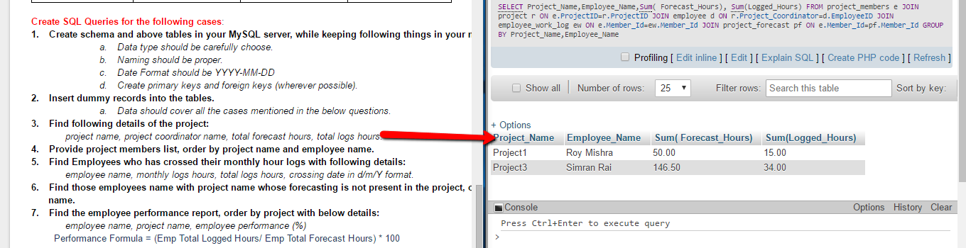

Q 2.  **Provide project members list, order by project name and employee name.**

**Ans.** SELECT e.* FROM project_members e LEFT JOIN project r ON e.ProjectID=r.ProjectID LEFT JOIN employee d ON e.EmployeeID=d.EmployeeID ORDER BY Project_Name, Employee_Name;

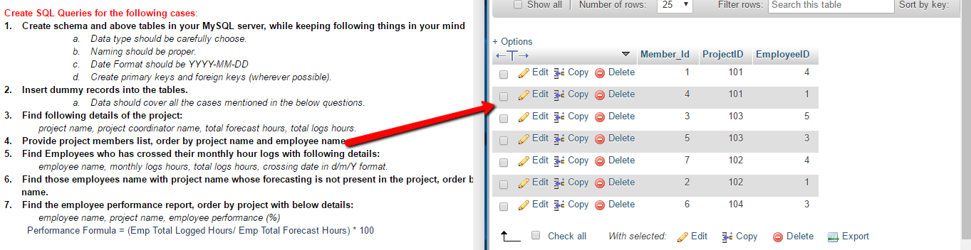

Q3.  **Find Employees who has crossed their monthly hour logs with following details:**

*employee name, monthly logs hours, total logs hours, crossing date in d/m/Y format.*

Ans.

SELECT employee.Employee_Name,employee.EmployeeID, SUM(ifnull(worked,0)) as Total_Hours FROM employee

left JOIN

(SELECT employee_work_log.Member_Id ,SUM(employee_work_log.logged_hours) as worked, project_members.EmployeeID as emp_id FROM employee_work_log,project_members WHERE employee_work_log.Member_Id=project_members.Member_Id GROUP BY employee_work_log.Member_Id) t1

ON employee.EmployeeID=t1.emp_id GROUP BY employee.EmployeeID

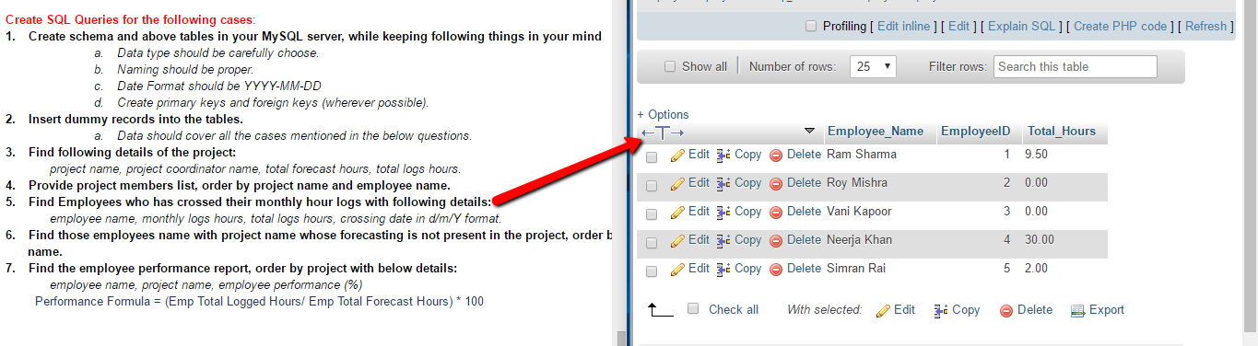

Q4. **Find those employees name with project name whose forecasting is not present in the project, order by project name.**

**Ans.** SELECT project_name,employee.Employee_Name from employee INNER JOIN (

SELECT project.Project_Name,t1.EmployeeID FROM project INNER JOIN (

SELECT ProjectID, EmployeeID from project_members WHERE not EmployeeID IN(

SELECT DISTINCT project_members.EmployeeID FROM project_members,project_forecast WHERE project_members.Member_Id = project_forecast.Member_Id) )t1 on project.ProjectID=t1.ProjectID)t2 ON employee.EmployeeID=t2.EmployeeID;

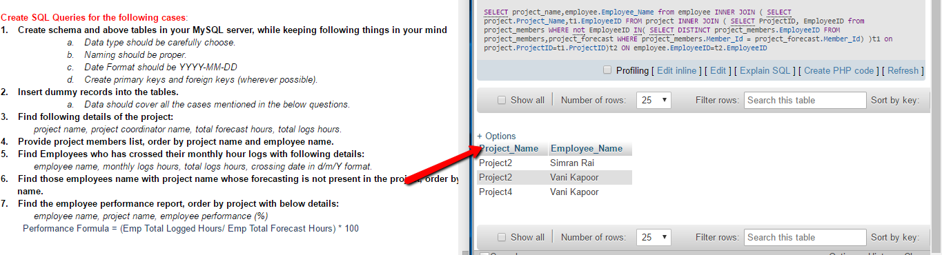

Q5.  **Find the employee performance report, order by project with below details:**

*employee name, project name, employee performance (%)*

SELECT DISTINCT employee.Employee_Name,ProjectID,Performance FROM employee INNER JOIN (

SELECT project_members.EmployeeID,project_members.ProjectID ,Performance FROM project_members INNER JOIN (

(SELECT t1.Member_Id, ((t1.Total_work/t2.forecast_hours)*100) as Performance FROM

(SELECT project_members.Member_Id, SUM(employee_work_log.logged_hours) as Total_work from project_members,employee_work_log WHERE project_members.Member_Id=employee_work_log.Member_Id GROUP BY project_members.Member_Id) t1

INNER JOIN

((SELECT project_forecast.Member_Id ,SUM(forecast_hours) as forecast_hours from project_forecast,project_members WHERE project_forecast.Member_Id= project_members.Member_Id GROUP BY Member_Id) t2) on t1.Member_Id=t2.Member_Id)) t3 ON project_members.Member_Id=t3.Member_Id) t4

